Artists in Residency Program- Summer

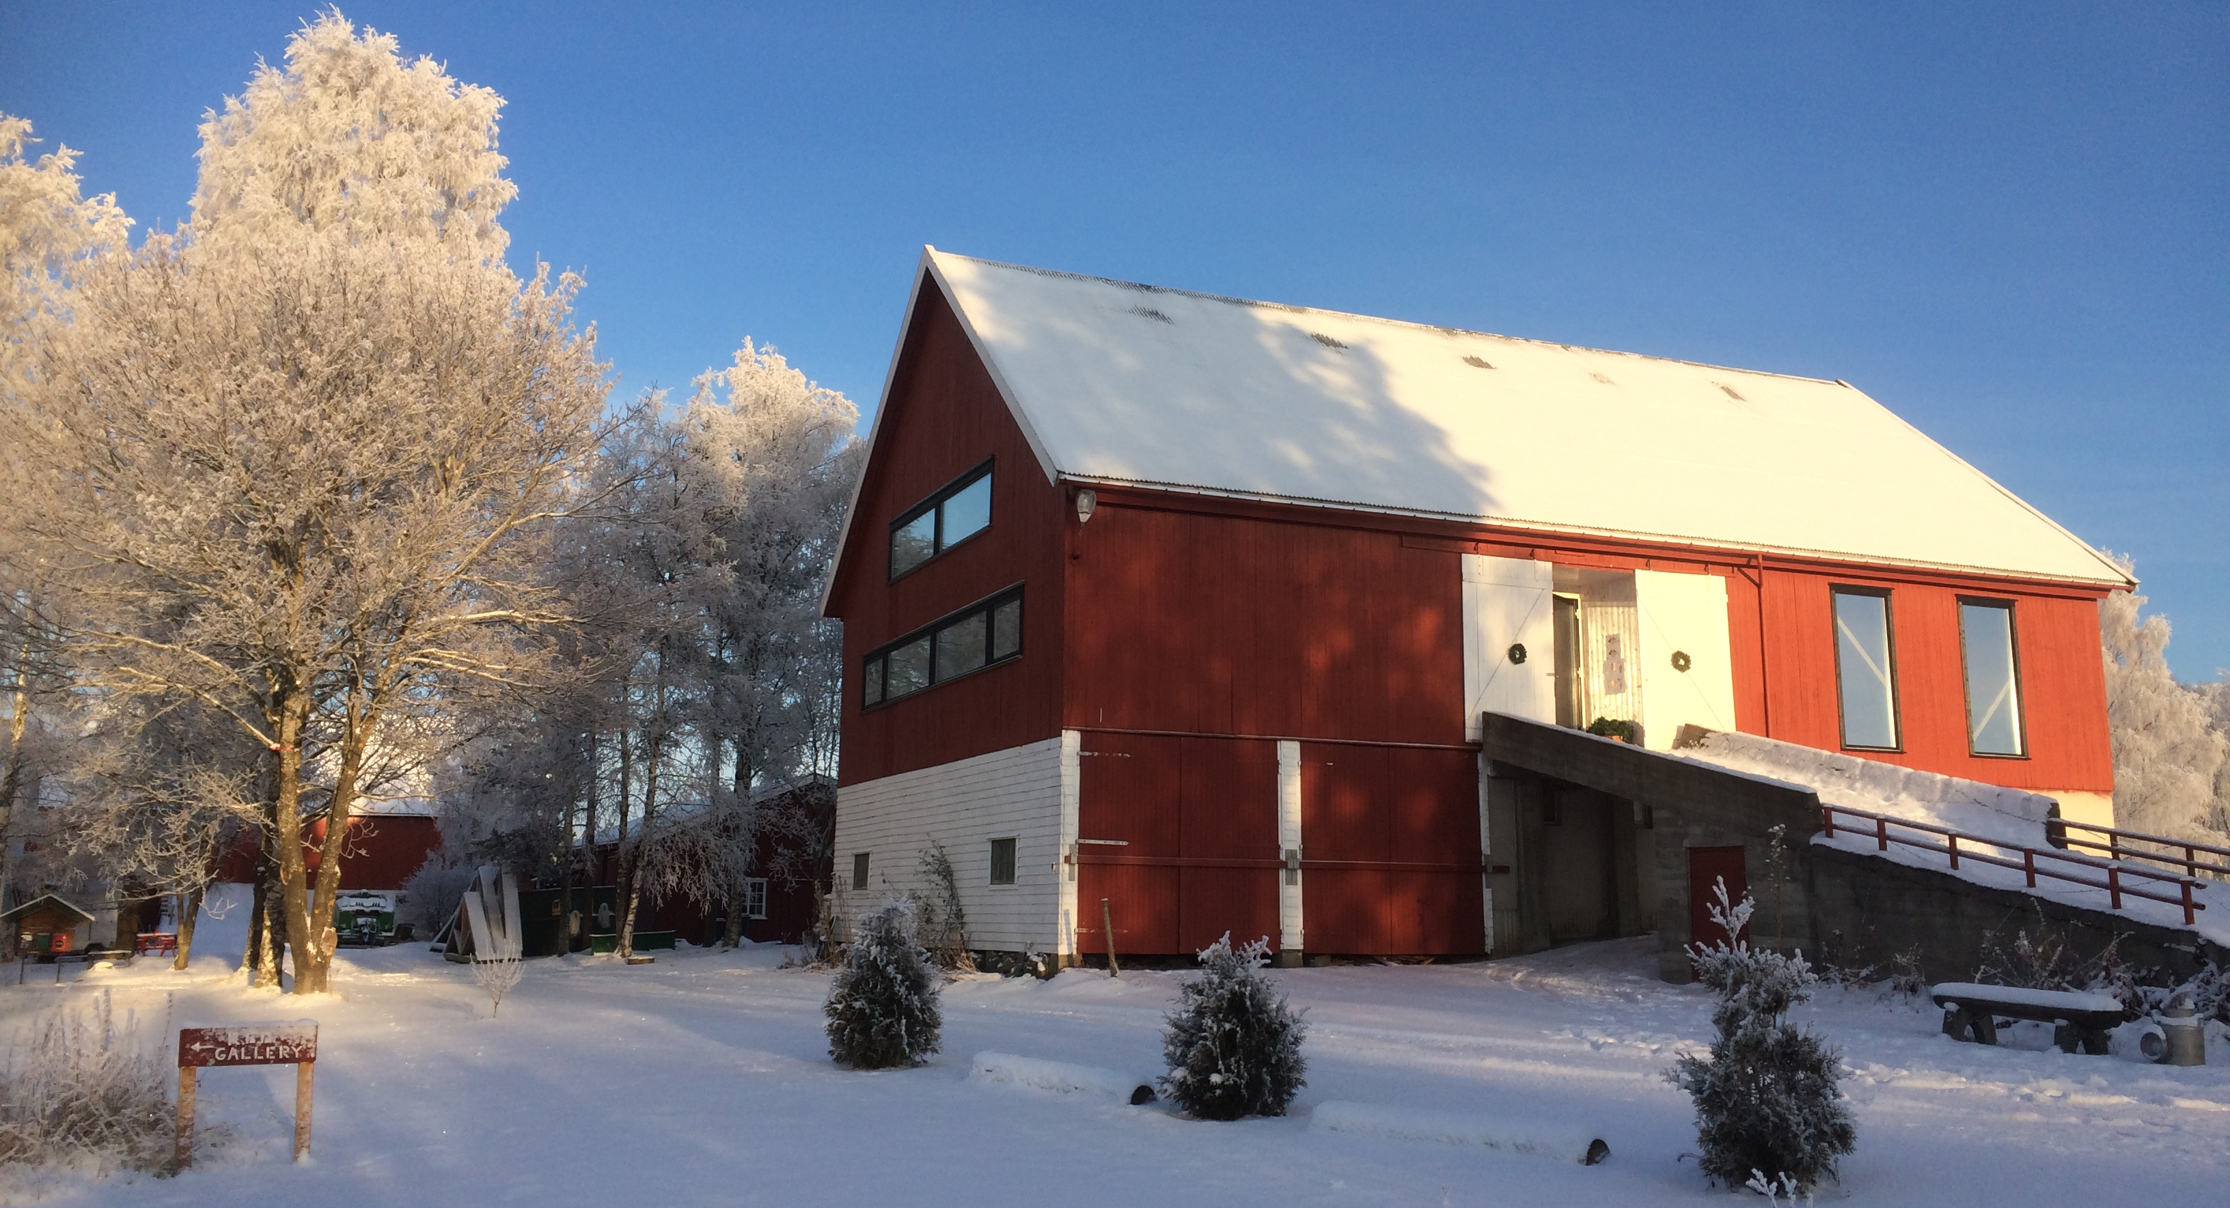

Application deadline:
1st of March for the Summer Residency (from June, 1st to August, 31st). Admitted applicants will be noticed after 4 weeks.
In the Summer Residency we offer free use of the heated studio (sprung dance floor measuring 19x12 meters, 8,5 meters height) and housing, and a work in progress/performance in the end of the stay.
NB. You will need to arrange your own transportation (a car is recommended).

Please submit the form in English or Norwegian to: red.residency.danz@gmail.com

Applicant
Group: ……………………………………………........................................................................................................................
Artistic director: ...................................................................................……………….....................……..........................
Address: ………………………………………………………………………..........................................................................................
Postcode/City: ........................................................... Country: ...............................................................................
Tel.: ........................................................................... Mobile: .................................................................................
E-Mail: ....................................................................... Homepage: www....................................…............................
Contact person: ........................................................................................................................................................
E-Mail: ...................................................................……..........………...........................................................................
Tel.: ..............................................................…………… Mobile: .................................................................................

Date: Signature:

Project description
Title: ........................................................................................................................................................................
Genre (artistic field):................................................... Number of participants: …....................................................

Short description:

Theme:

Planned timeframe -Preparation, rehearsals, premiere-:

Project participants -Name, role/task in project-:

Planned outcome of residency at R.E.D. (work in progress/performances/lectures/workshops/etc):

Please include the following in the application:
O project description including a short description of your motivation to apply for the residency
O Link to Vimeo/You tube- for previous or current work
O CV and Press coverage (max. ½ page per person)
O other: ..............................................................................................................................................................

Requirements
Studio, rehearsal and workspace requirements:
(Please inform us about the required needs, primarily in the production room/studio)

O free access to the wood
O free access to the field (season regulated)
O gallery (3 small exhibition/installation rooms)
O multiple screening rooms
O café theatre with 3,5x3,5 meter stage
O small space available for carpentry

Special requirements: .........................……………..…...................................................................................................
..................................................................................................................................................................................

Preferred dates of residency– not binding (summer: max. 2 weeks between June, 1st and August, 31st):
...............................................................................................................................................................................................................................
Alternative: ............................................................................................................................................................................................................
Number and role of project participants who will be present during the project on R.E.D.):
For the whole project: ..............................................................................................................................................
..................................................................................................................................................................................
..................................................................................................................................................................................
Temporarily: .............................................................................................................................................................

(The details on this page are for us to understand the size of the project and your potential demand. Please contact us if there are any major changes.)

Any additional comments, wishes, needs, ideas or suggestions:

……………………………………………………………………………………………………………………………………………………………………………...

For the statistic, how did you get to know about the call for application?

